Scenario 4: Same Account access to the S3 bucket via IAM.
testuser wants to access an S3 bucket of suchi account.
Both IAM users belong to the same AWS account, so access can be granted using Identity-Based IAM Policies (no bucket policy needed unless we want cross-account access).
Using IAM Policy (Identity-Based Policy)
Step1: we could see that under Suchi account he has created an s3 bucket.
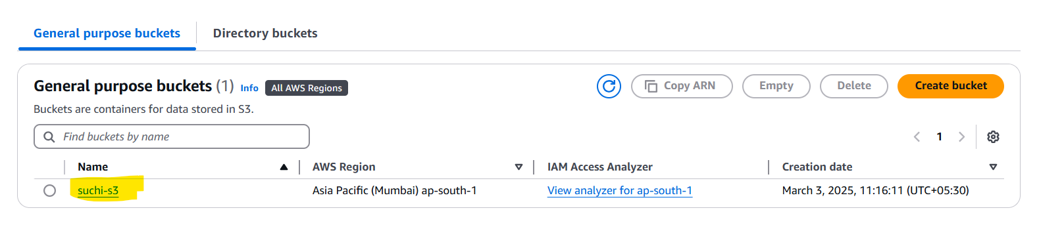
But user testuser is not allowed to create/view the s3 bucket.
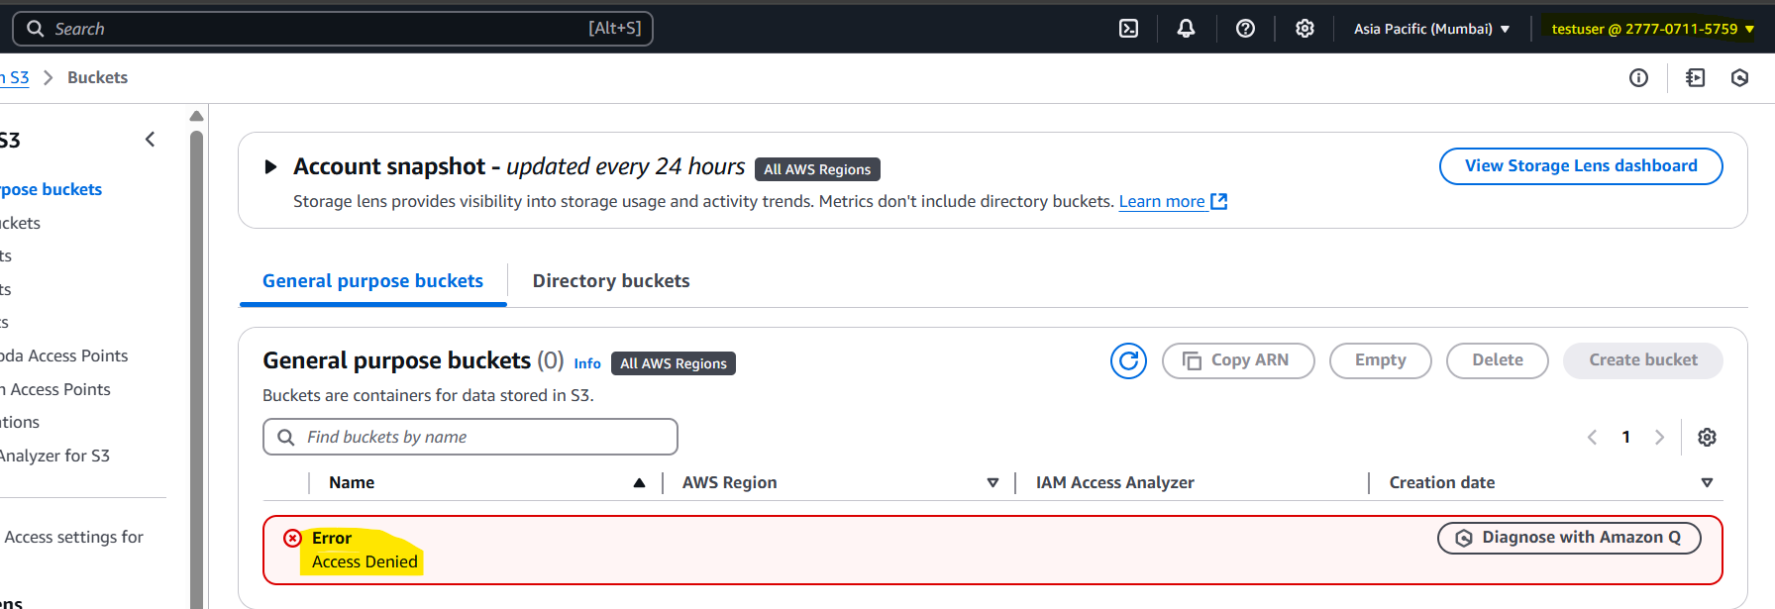
Step 2: lets provide an access to testuser account
IAM >users >locate user Testuser > click on add permission.
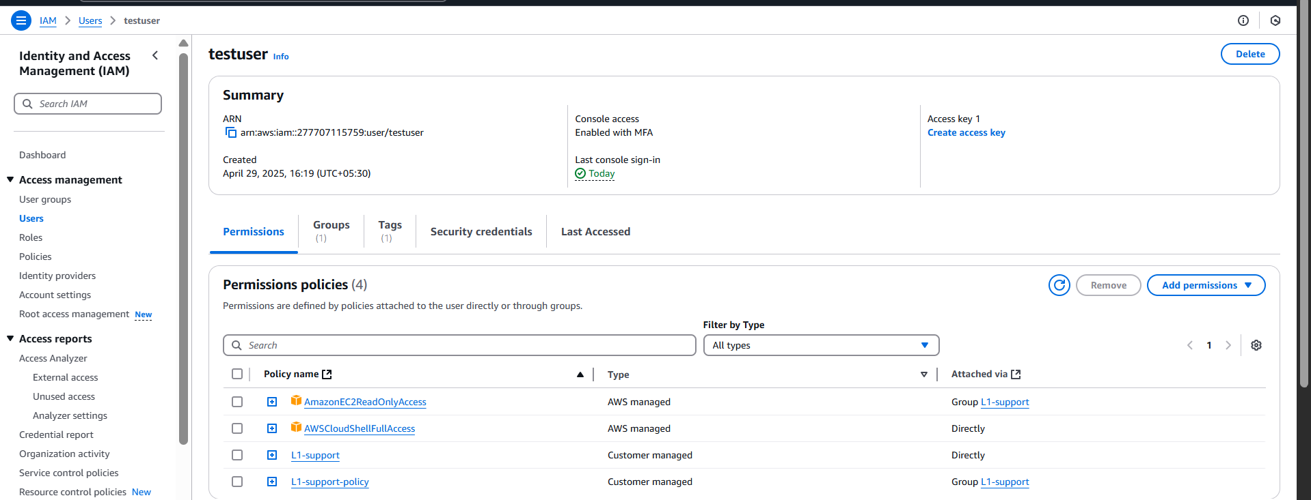
Step 3: select attach policies directly and select Amazons3ReadOnlyAccess
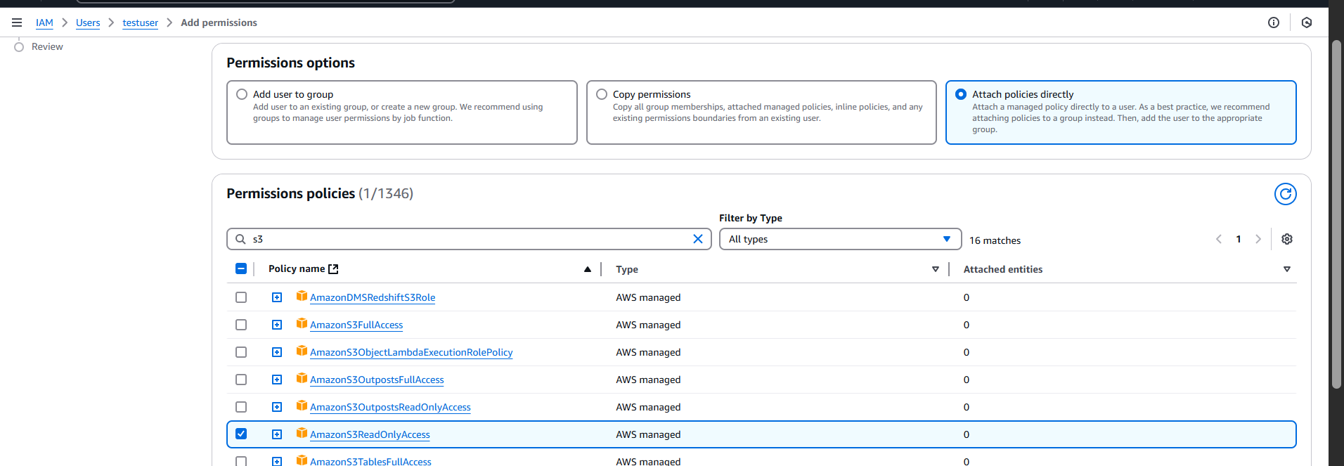
Step 4: lets validate in testuser
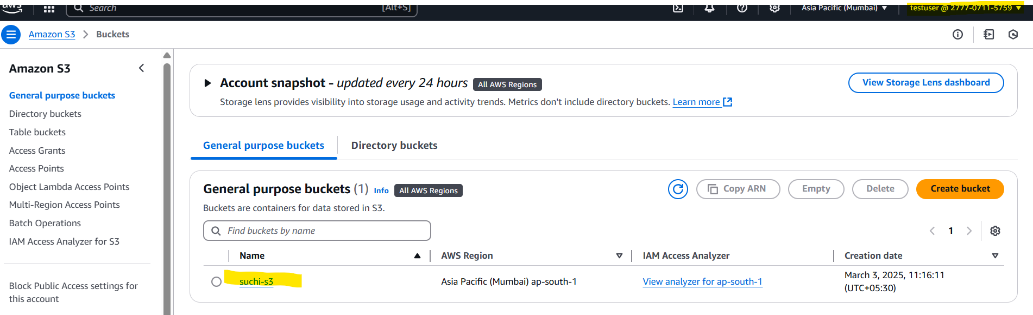
Testuser can view the contents of the suchi’s account s3 bucket.
It didn’t ask for suchi to provide an explicit allow access. Because both testuser and suchi are created within the same AWS account – 277707115759. (Mumbai)
And Ensure there is no explicit block in bucket policy.

